AUTO TICKET CLASSIFICATION USING FLOW DESIGNER

PROJECT TESTING PHASE
School IT Helpdesk — ServiceNow No-Code Automation

1. Testing Introduction
The Project Testing Phase is carried out to verify that the Auto Ticket Classification using Flow Designer solution works according to the requirements defined during the project development. The testing focuses on the complete ticket-processing workflow, starting from creation of an IT support ticket and continuing through automatic Category and Subcategory assignment.
The testing also verifies that the classification rules operate correctly for the entered Short Description and that the notification step is executed after the ticket is processed. Both the ticket record and email output were reviewed as part of the testing evidence.

2. Testing Objectives
• Verify that a new Incident WorkFlow record can be created successfully.
• Verify that the Short Description is correctly used for ticket classification.
• Verify that the expected Category is automatically assigned.
• Verify that the expected Subcategory is automatically assigned.
• Verify that the generated ticket number is available on the record.
• Verify that the email notification is generated for the caller.
• Confirm that the complete workflow produces the expected output.

3. Test Scenario – Network Issue
A test ticket was created in the Incident WorkFlow table using the Short Description “My College Has issue with Network”. The purpose of this test was to check whether the Flow Designer automation identifies the Network keyword and assigns the corresponding classification.
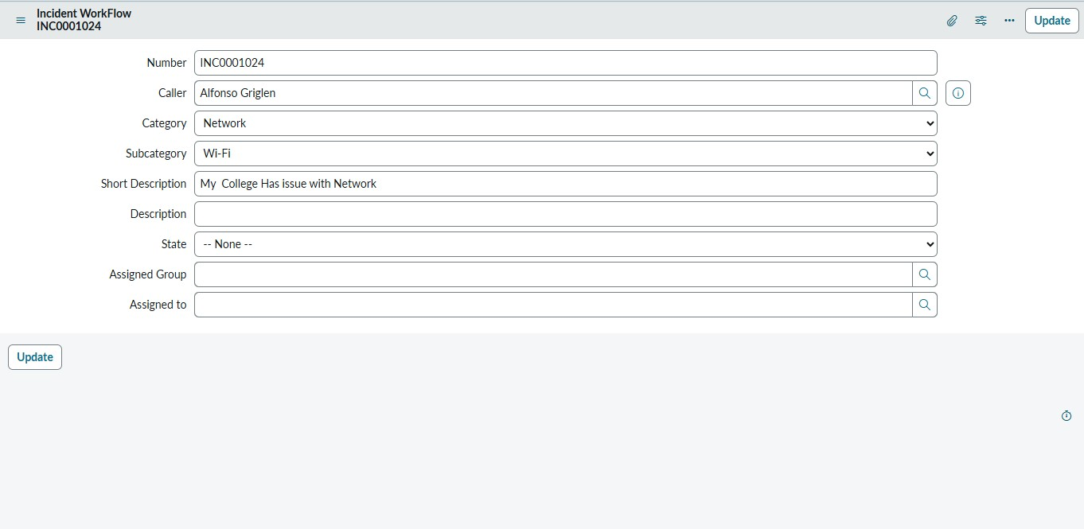
Fig. 1 – Test ticket INC0001024 showing Short Description = Network issue, Category = Network and Subcategory = Wi-Fi
The test record shows ticket number INC0001024. The Category field is populated as Network and the Subcategory field is populated as Wi-Fi. This provides evidence that the ticket classification output was applied to the record after processing.

4. Classification Verification
The Network/Wi-Fi test confirms the expected relationship between the issue description and the classification values. The result was checked directly on the Incident WorkFlow record. The ticket contains the original issue description while the classification fields contain the automatically assigned values.
• Input keyword / issue: Network
• Ticket number: INC0001024
• Expected Category: Network
• Expected Subcategory: Wi-Fi
• Observed result: Network / Wi-Fi

5. Email Notification Testing
After the ticket classification step, the Send Email action was tested to verify that the caller receives a confirmation notification. The email records were checked in ServiceNow to verify that the configured subject was generated and that the notification was prepared for the caller.
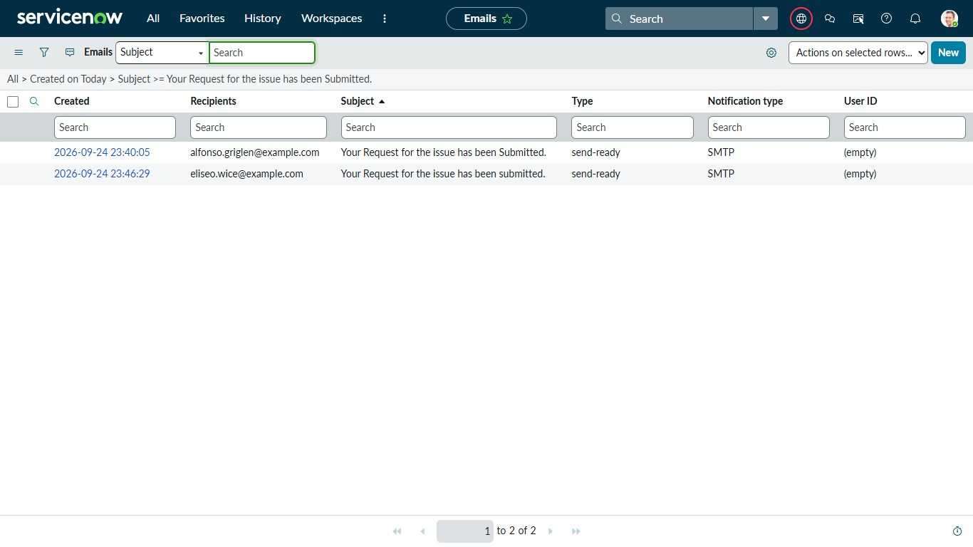
Fig. 2 – ServiceNow Emails list showing generated notification records with the configured subject
The email list displays the generated notification entries with the subject “Your Request for the issue has been Submitted.” The recipient information and send-ready status provide evidence that the notification action was executed.

6. Email Content Verification
The email preview was opened to verify the actual notification content. The preview confirms that a message was generated and made available through the email notification process.
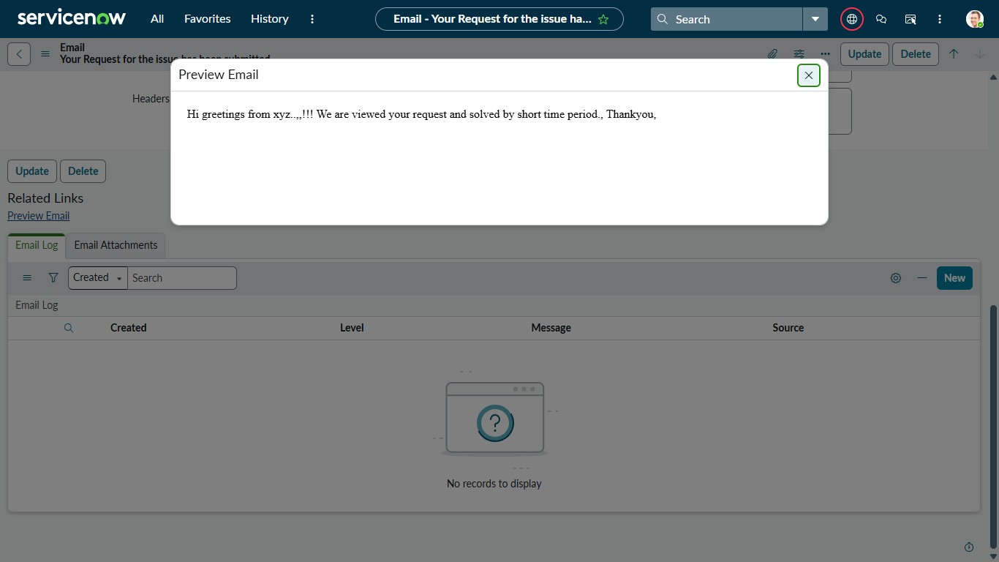
Fig. 3 – Preview Email screen showing the generated confirmation message
7. Expected Result and Observed Result

• Ticket creation: Expected – a new Incident WorkFlow record is created. Observed – ticket INC0001024 was created.
• Network classification: Expected – Category = Network. Observed – Category = Network.
• Subcategory classification: Expected – Subcategory = Wi-Fi. Observed – Subcategory = Wi-Fi.
• Ticket identification: Expected – unique INC number. Observed – INC0001024.
• Email notification: Expected – confirmation email generated. Observed – notification record and email preview were available.

8. Overall Testing Outcome
The testing activities verified the main functional path of the Auto Ticket Classification using Flow Designer project. The Network issue test produced the expected Network and Wi-Fi classification on the Incident WorkFlow record. The email testing also verified that the configured confirmation notification was generated and could be viewed in the ServiceNow email records.
Based on the executed test scenario and the captured screenshots, the tested workflow demonstrates the intended sequence of ticket creation, automatic classification, and caller notification. Additional classification keywords can be tested using the same procedure to expand the test coverage.

